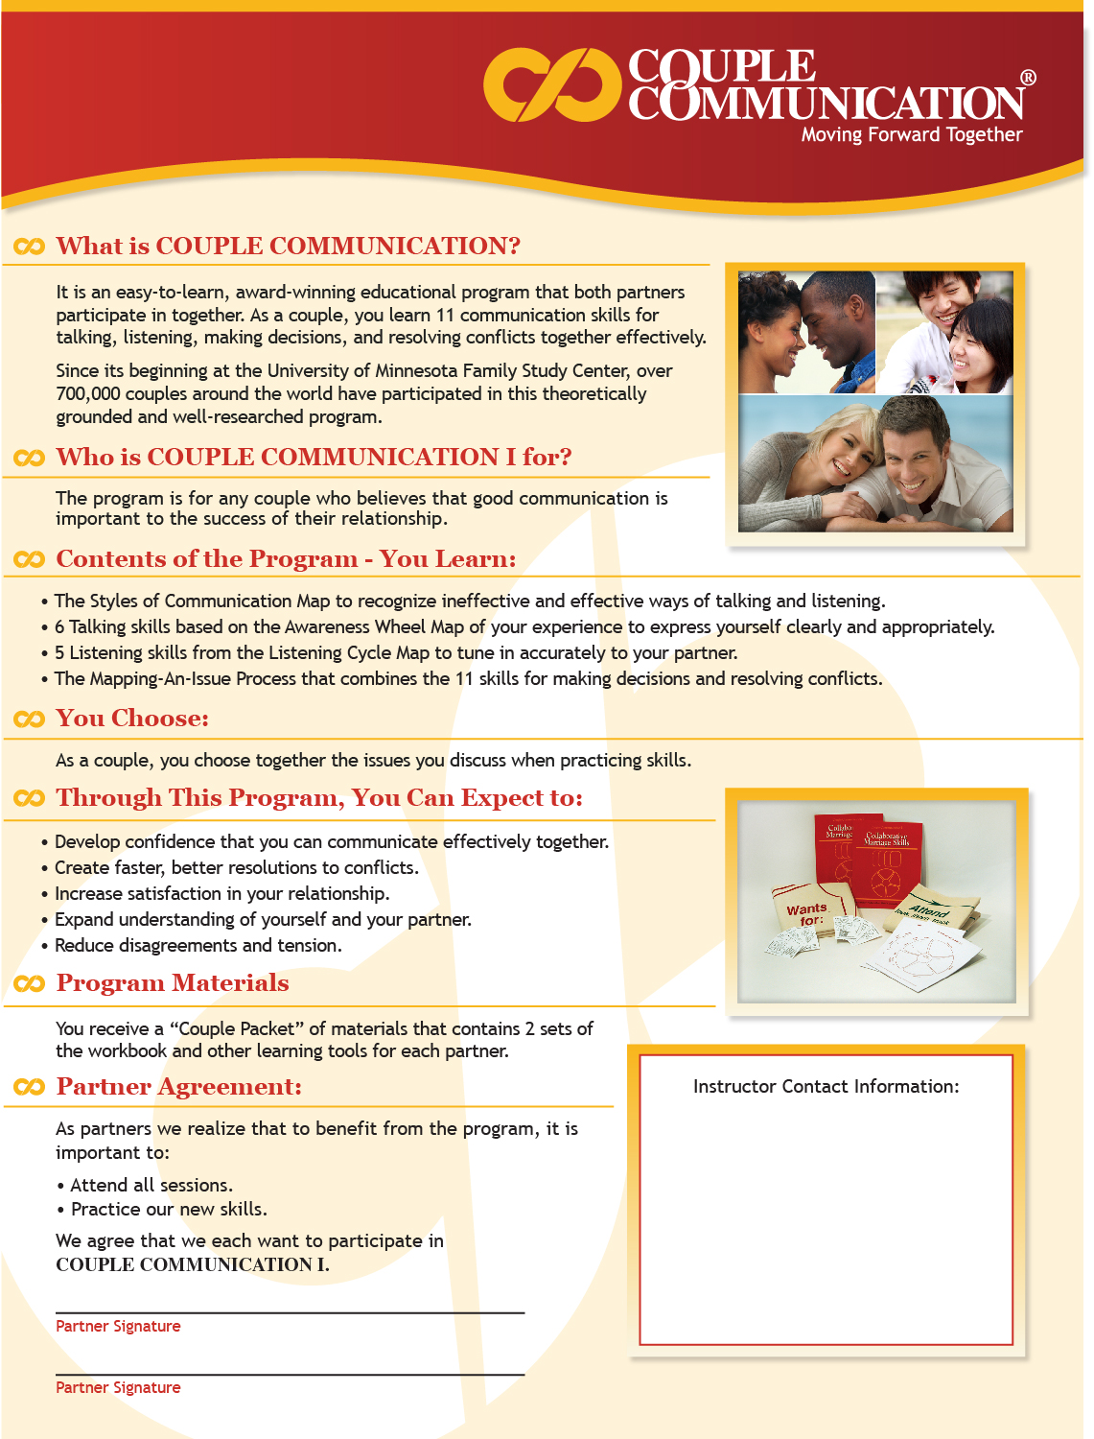

Dr. James Scott, Jr.
Founder & President,
Scott Free Clinic
ScottFreeClinic.org

dr.scott@ScottFreeClinic.org

